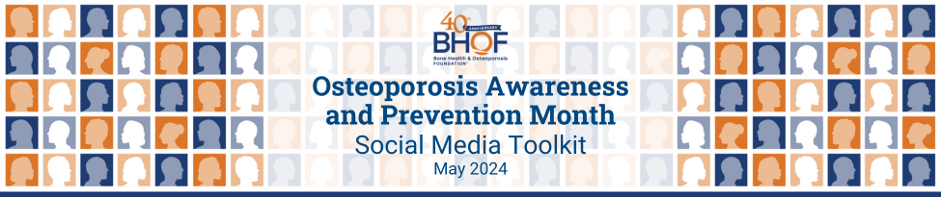

May is Osteoporosis Awareness and Prevention Month!

Join the Bone Health & Osteoporosis Foundation (BHOF) in raising awareness about bone health and osteoporosis during Osteoporosis Awareness and Prevention Month in May!

Osteoporosis is a common condition that affects millions of people worldwide. In fact, approximately 54 million Americans have low bone density or osteoporosis. It is a progressive disease that weakens bones, making them more fragile and susceptible to fractures. Osteoporosis Awareness and Prevention Month is observed every May to educate people about bone health and the importance of taking preventative measures.

This toolkit provides a collection of social media posts and graphics that you can use to help raise awareness. By using these resources to spread the word about osteoporosis, we can help prevent this disease from taking a toll on people's lives. Let’s work together to promote good bone health and prevent serious broken bones!

40 Patient Stories to Commemorate 40 Years
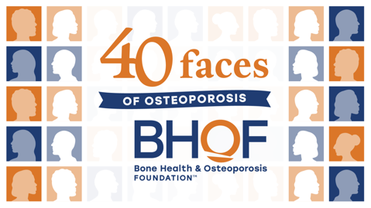
We are excited to share that 2024 marks the 40th anniversary of the Bone Health & Osteoporosis Foundation! Our mission has never been more critical given the fact that osteoporotic fractures are responsible for more hospitalizations than heart attacks, strokes, and breast cancer combined.

People’s experience with osteoporosis varies greatly, but the good news is that it is manageable disease. In commemoration of our 40th anniversary we will be highlighting the stories of 40 inspiring osteoporosis patients via inspirational videos throughout the year, starting in May. Follow along to learn about the many ways that this condition affects people from all walks of life.

Click here to visit the Osteoporosis Awareness and Prevention Month page.

Help us spread the word!

Tag BHOF in your posts so we can share/amplify!

Facebook: @bonehealthandosteoporosisfoundation
X (formerly Twitter): @bonehealthBHOF
LinkedIn: @bonehealthandosteoporosis
Instagram: @bonehealthandosteoporosis
Use the following hashtags:

#OsteoporosisAwareness
#OAPM2024
#BeBoneStrong
#40FacesOfOsteoporosis
#FacesOfOsteoporosi

Additional tips:
- Personalize posts or copy and paste the suggested text we’ve provided.
- Encourage your social media followers to get involved and spread the word!
- Share and repost BHOF content throughout the month.

Don’t miss these items and events! In addition to the suggested social media posts, you can share info about these initiatives as well:
- Free Webinars
- Bone Talk Podcast
- Support Groups
- Your Path to Good Bone Health
- Informational Resources and Guides
- Patient Registry

Suggested Social Media Posts

Click here to download a zipped folder of the accompanying graphics.

May is Osteoporosis Awareness and Prevention Month! Help me raise awareness and get involved by visiting https://www.bonehealthandosteoporosis.org/awareness-month! #OsteoporosisAwareness #BeBoneStrong #OAPM2024
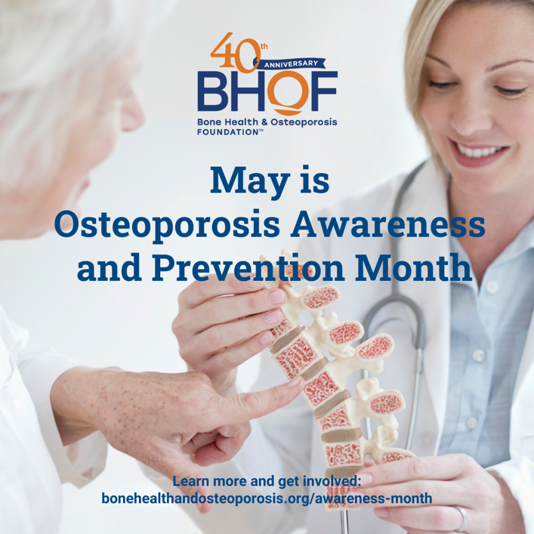

Starting in May, and throughout the year, BHOF is commemorating its 40th anniversary by sharing 40 patient video stories to raise awareness about bone health and osteoporosis. Learn more here: https://www.bonehealthandosteoporosis.org/awareness-month! #BeBoneStrong #OsteoporosisAwareness
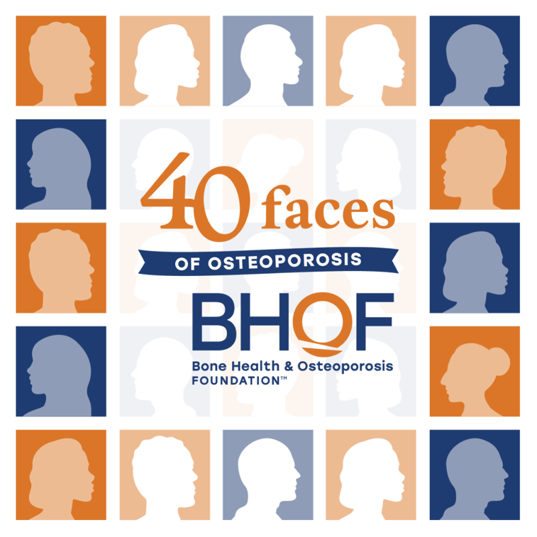

Osteoporosis is a bone disease that occurs when the body loses too much bone, makes too little bone, or both. As a result, bones become weak and may break form a fall or other causes. Osteoporosis means “porous bone.” Learn more: https://www.bonehealthandosteoporosis.org/awareness-month! #BeBoneStrong #OAPM2024 #OsteoporosisAwareness
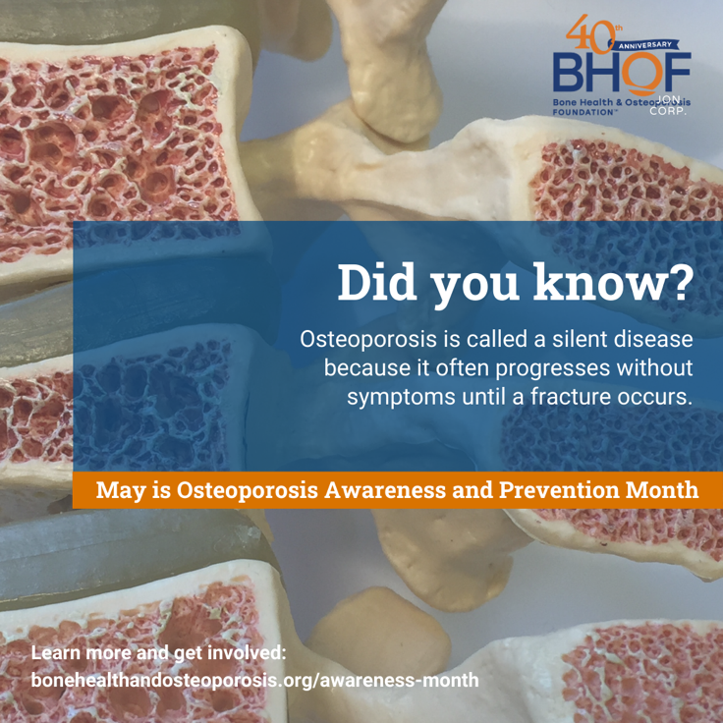

Childhood and young adulthood are bone-building years! Weight-bearing exercise, a healthy diet rich in calcium, and getting enough vitamin D are important for reaching peak bone mass. Learn more and help spread awareness about bone health: https://www.bonehealthandosteoporosis.org/awareness-month #OsteoporosisAwareness #BeBoneStrong #OAPM2024
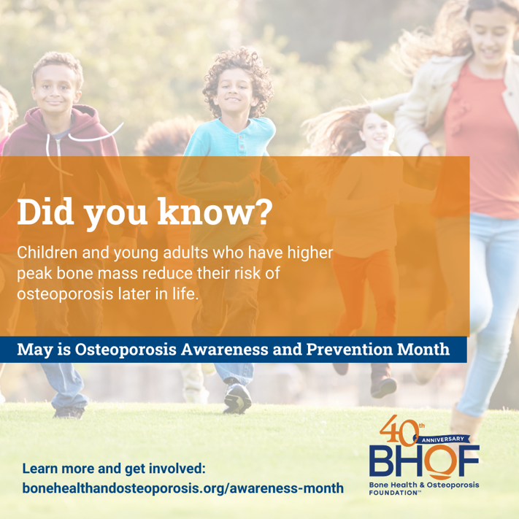

Women can lose up to 20% of bone mass in the first 5-7 years post-menopause. Learn more and find resources to promote bone health during May’s Osteoporosis Awareness and Prevention Month: https://www.bonehealthandosteoporosis.org/awareness-month #BeBoneStrong #OAPM2024 #OsteoporosisAwareness
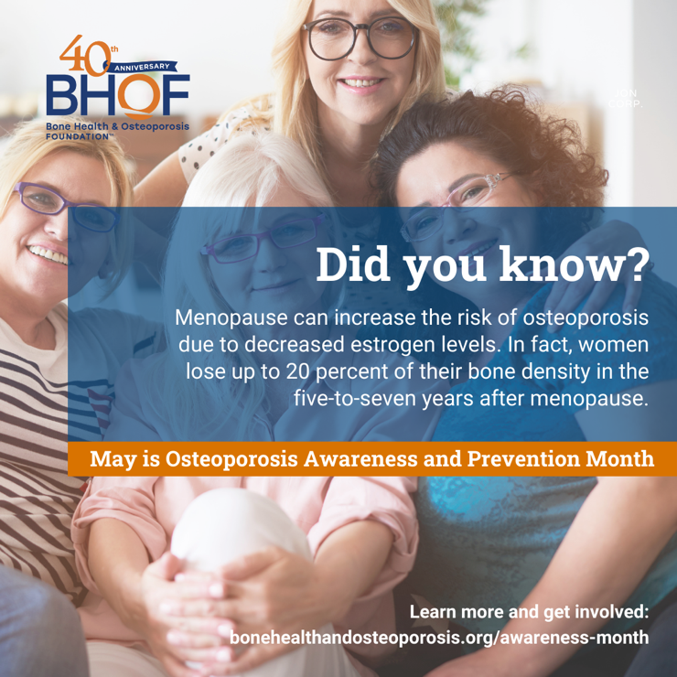

Calcium is a key building block of bones, while vitamin D helps with calcium absorption. Learn more and help spread awareness about bone health: https://www.bonehealthandosteoporosis.org/awareness-month #OsteoporosisAwareness #BeBoneStrong #OAPM2024
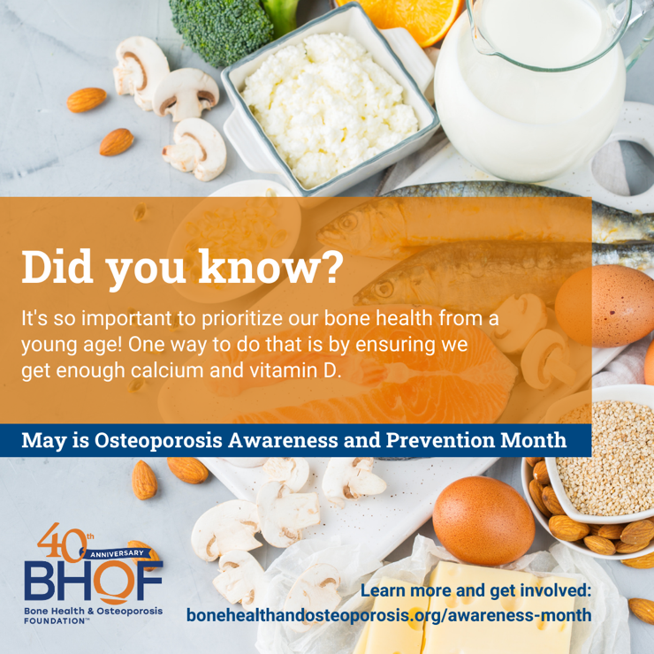

Did you know that men older than 50 are more likely to break a bone due to osteoporosis than they are to get prostate cancer? Learn more and find resources to promote bone health during May’s Osteoporosis Awareness and Prevention Month: https://www.bonehealthandosteoporosis.org/awareness-month #BeBoneStrong #OAPM2024 #OsteoporosisAwareness
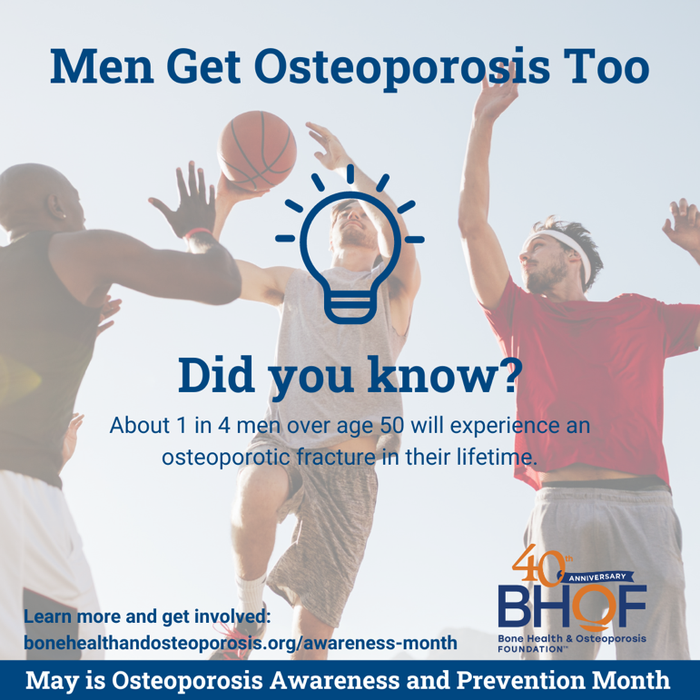

There are two types of osteoporosis exercises that are important for building and maintaining bone density: weight-bearing and muscle-strengthening exercises. Learn more and help raise awareness: https://www.bonehealthandosteoporosis.org/awareness-month #BeBoneStrong #OAPM2024 #OsteoporosisAwareness
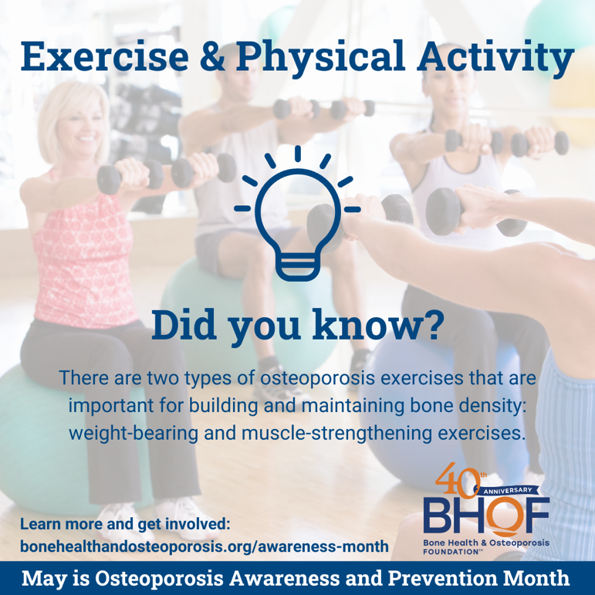

An estimated 54 million Americans have osteoporosis or low bone mass! Learn more and help raise awareness during May’s Osteoporosis Awareness and Prevention Month: https://www.bonehealthandosteoporosis.org/awareness-month #BeBoneStrong #OAPM2024 #OsteoporosisAwareness
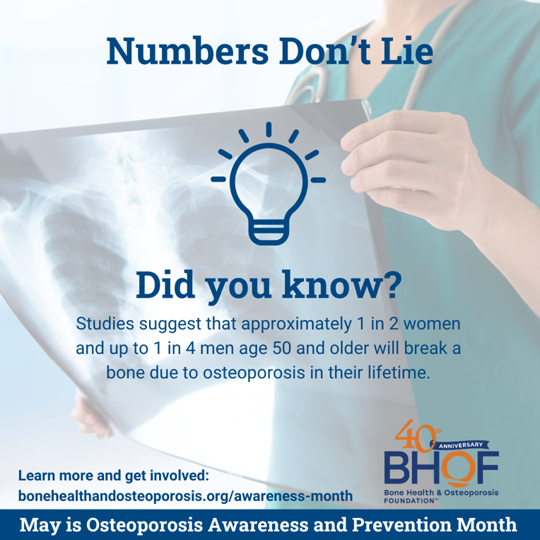

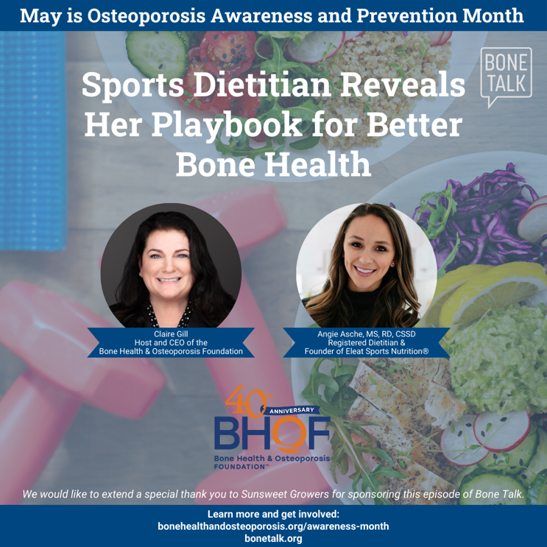
Tune in to the latest episode of Bone Talk! Angie Asche, MS, RD, CSSD, joins BHOF CEO Claire Gill to discuss how physical activity and nutritional intake directly affect bone health. As a registered dietitian, Angie has worked with hundreds of high school, college, and professional athletes nationwide, educating them on how best to fuel their bodies and achieve top physical performance. Listen here: https://www.bonetalk.org/podcast-episodes/sports-dietitian-reveals-her-playbook-for-better-bone-health

